CODE2CAREER
WEEK : 3
TOPICS : JavaScript Part-1

📁 Students must create a folder named 'Week 3'. Inside it, create subfolders for each day (Day 1 to Day 6).
📂 For Days 1 to 5, each topic you study must be practiced by creating a separate `.js` file with your code and comments.
📂 For Day 6, solve each of the provided questions in individual files (e.g., q1.js, q2.js...) and submit in the Day 6 folder.

DAY 1
- What is JavaScript? why JavaScript is both a scripting language and a programming language.
- What is a Variable?

  - let,const,var
  - Variable Reassignment and Redeclaration
  - What is Scope?

ANSWER:-
VARIABLES:- To store the datas which is related to program in the computer memory.

Let,Const,Var
To declare variables in javascript by 3 types. They are:-
*var:-

*const:- WE CAN USE IN MAP

*Let:-WE CAN USE IN LOOP

Variable Reassignment and Redeclaration

// Declare a variable
var n;

//Redeclare this variable
var n;

//Assign it a value
n=6;

//Reassign it another value
n=7;

//Declare a variable and assign it a value
var m=6;

Reassignment and Redeclaration depends upon how they have been declared and by using which keyword.
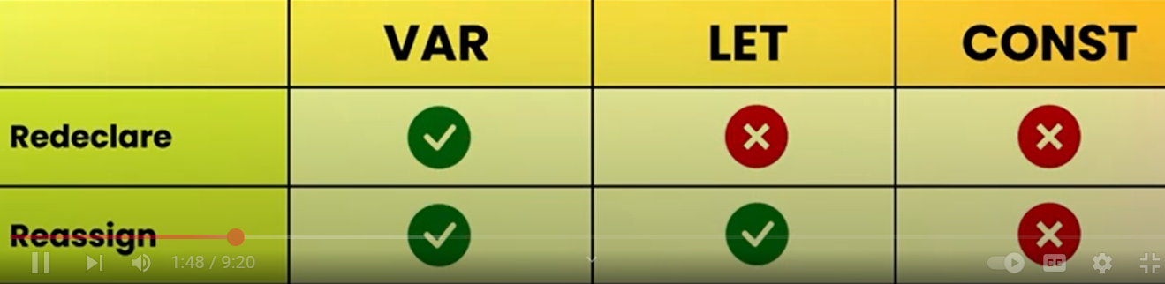

CONST cant reassing.But if we push, we can add values.

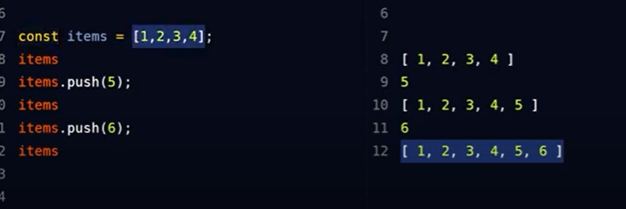

SCOPE

Scope means where the variable can visible in which function.
Depends upon function. There are two types of scope
1)Global scope:-
Can use anywhere In the code. Inside the function or outside the function or block.

Eg:-let name = "Shanu"; // Global variable

function greet() {
console.log("Hello " + name); // Can access global variable
}

greet();
console.log(name); // Can access here too

a) Block scope :- Works only inside {}
If you declare a variable using let or const inside { }, it's only accessible inside that block.

eg:-

{
let age = 25;
const city = "London";
console.log(age); // ✅ OK
console.log(city); // ✅ OK
}

console.log(age); // ❌ Error
console.log(city); // ❌ Error

b)Function scope
Variables declared using var inside a function are only accessible inside that function.

Eg:-
function sayHello() {
var message = "Hello!";
console.log(message); // ✅ Works inside
}

sayHello();
console.log(message); // ❌ Error: message is not defined

- JavaScript Data Types - Primitive Data Types, Non-Primitive (Reference) Data Types

Primitive Data type:-
- Can hold only single value.
- Are immutable:- their values once assigned cannot be change.
- Eg:- Number,string,Boolean,undefined,null are primitive datatypes.
- They are simple datatypes.

Non-Primitive Data type:-

- Can hold multiple Values.
- Are Mutable:- Their values can change.
- Eg:- Object, array,function,RegExp, are non-primitive datatypes.
- They are complex datatypes.

- Type Conversion in JavaScript – implicit,explicit
Type conversion is the process changing datatype of a value to the datatype of another value. Eg:- Strings--> number
number-->boollean
boollean --> numbers etc
Javascriot do this in two ways:-

1. Implicit Type Conversion (Type Coercion)
Automatic by Javascript.

Eg:-
let result = 5 + "2";
console.log(result); // "52" (number 5 is converted to string)
Eg 2:-
let result = true + 1;
console.log(result); // 2 (true becomes 1)

Eg 3:-
console.log("10" == 10); // true → string "10" is converted to number

2. Explicit Type Conversion (Manual)
By manually.

Eg:-String Conversion
let num = 100;
let str = String(num); // turns number into string "100"
console.log(str); // "100"
console.log(typeof str); // string

Eg 2:-Number Conversion
let str = "45";
let num = Number(str); // turns "45" into number 45
console.log(num); // 45
console.log(typeof num); // number

Eg 3:- Boolean Conversion
let value = Boolean(0); // false
console.log(value); // false

let name = Boolean("Shanu"); // true (non-empty string = true)
console.log(name); // true

- Falsy Values in JS

If Boolean true, truthy values. If Boolean false, falsy values.

FALSY VALUES:-
- Zero
- Null
- Undefined
- Empty string
- Not a Number(NaN)

- JavaScript Operators

Operators are special symbol. We can do operation with two values.
  - Arithmetic
  - Addition
var a=20;
var b= 10;
document.write(a+b);

  - Subtraction
document.write(a-b);
  - Multiplication
document.write(a*b);
  - Division
document.write(a/b);
  - Modulus
var a=10;
var b= 3;
document.write(a%b);
  - Increment
var a=20;
a--; //means (a+1 ) answer is 21.
document.write(a);
  - Decrement
var a=20;
a--; //means (a-1) answer is 19.
document.write(a);
  - Exponentiation
To find square,cube etc...
document.write(2** 2); // answer is 4
document.write(10**3); //answer is 1000

  - comparison
For comparing.
  - logical operators
  - Ternary operator
The ternary operator is a shortcut for writing an if...else statement.
It has three parts, so it's called "ternary"
Eg:- condition ? expression_if_true : expression_if_false;

  - Typeof Operator
The typeof operator tells you the type of a variable or value.
It helps you know what kind of data you are working with, like:
- Is it a number?
- A string (text)?
- A boolean (true/false)?
- Or something else?

  - Nullish coalescing operator ??

Provide default values
The ?? operator returns the right-hand value only if the left-hand value is null or undefined.

let result = value1 ?? value2;
If value1 is not null or undefined, it returns value1

If value1 is null or undefined, it returns value2

  - Difference between || and ??
Use || when you want to replace any falsy value
Use ?? when you only want to replace null or undefined

let score = 0;

let result = score || 100; // returns 100
let result2 = score ?? 100; // returns 0

console.log(result); // 100 (because 0 is falsy)
console.log(result2); // 0 (because 0 is NOT null/undefined)

- Conditional statements

- if
- if...else
- if...else if...else
- switch
- ?: (Ternary operator – short form)

- JavaScript Loops

Types of Loops in JavaScript
- for loop
- while loop
- do...while loop
- for...of loop (for arrays)
- for...in loop (for objects)

Day 2
- Functions in js
  - Function Declaration
  - Function Expression
  - Arrow Function
  - Anonymous Function
  - Named Function Expression
  - Callback Function
  - First-Class Functions
  - Higher-Order Functions
  - Factory Function
  - Generator Function
- Lexical Scope vs Dynamic Scope

Day 3
- Arrays in js
  - Array Properties
  - Common Array Methods
  - Array Iteration Methods
- JavaScript Strings
  - String Property
  - String Methods
- Regular Expressions (RegEx)
- Literals
Day 4
- JavaScript Objects
  - Object Methods
  - Shorthand Method Syntax
- Constructor function
- This
  - Call, apply,bind
- Arrays of Objects & Nested Structures
  - Array of objects
  - Array inside object
  - Nested objects
- in operator
- Optional chaining ?.

Day 5
- Spread Operator & Destructuring,rest operator
  - Nested Destructuring
- Prototype & Inheritance
- JSON (JavaScript Object Notation)
  - Convert JS Object ⇄ JSON String
- Shallow vs Deep Copy + structuredClone()

Day 6
1. What is the output and why?
console.log("5" - 1 + 1);
console.log("5" + 1 - 1);

2. Remove all falsy values from this array without using .filter():
[0, 1, "", "text", undefined, null, NaN, 42]

3. Predict and explain the results:
console.log(1 + true);
console.log("10" * "2");
console.log("10" + true);
console.log(undefined + 1);
4. Write a function that uses a callback to return the first vowel in a string.

5. Use reduce to flatten the array:
const data = [
{ name: "Ali", scores: [10, 20] },
{ name: "Sara", scores: [30, 40] }
];
Expected: [10, 20, 30, 40]

6. Use RegEx to check if a string starts with a vowel (a/e/i/o/u).

7. What will each log?
const user = {
profile: {
address: {
city: "Dubai"
}
}
};
console.log(user.profile?.address?.city);
console.log(user.profile?.contact?.phone);

8. Use destructuring with rest:
const [a, b, ...rest] = [10, 20, 30, 40];
console.log(a, b); // ?
console.log(rest); // ?

9. Explain object property shorthand:
const name = "Ali";
const age = 25;
const user = { name, age };
console.log(user);

10. Use call() to bind this:
function greet() {
return `Hello, ${this.name}`;
}
const user = { name: "Reem" };
console.log(greet.call(user)); // ?

11. Shallow copy vs deep copy:
const original = { name: "Ali", info: { city: "Dubai" } };
const copy = { ...original };
copy.info.city = "Abu Dhabi";
console.log(original.info.city); // ?

12. Demonstrate prototype inheritance:
const base = { role: "user" };
const admin = Object.create(base);
admin.name = "Aisha";
console.log(admin.role);

